Date Reviewed
January 2021

Course
Law Studies 12

Topic
Global dispute agencies and courts

Big Idea
A society’s laws and legal framework affect many aspects of people’s daily lives.

Essential Question
In what ways do international organizations and international law affect global change?

Learning Standards
Content:
Students are expected to know the following:
- Structures and roles of global dispute agencies and courts
  - International Court of Justice
  - World Trade Organization
  - United Nations

Curricular Competencies
Students are expected to be able to do the following:
- Assess and compare the significance and impact of legal systems or codes
  - Analyze the role of global dispute resolution institutions and agencies in international human rights and economic development issues
  - Analyze the role of the International Court of Justice (the World Court) at The Hague in cases involving human rights abuses

Core Competencies
Communication - I can effectively use presentation skills to communicate and analyze the role of global dispute resolution agencies in international human rights and economic development issues.

Thinking - I can evaluate facts, identify critical questions, and challenge assumptions and ideas to draw conclusions about the role and impact of global dispute agencies and courts.

Personal and Social - I can employ social awareness and responsibility by engaging in respectful discussion and exchanging ideas with my peers.

First People’s Principles of Learning
Learning ultimately supports the well-being of the self, the family, the community, the land, the spirits, and the ancestors.

Introduction
- Provide each student with a copy of the “Placemat Graphic Organizer”.
- The teacher will project three images of selected global dispute agencies and courts (The International Court of Justice, The World Trade Organization, and the United Nations).
- For each image, students have 20-30 seconds to write down any and all words that come to mind in one of the three placemat sections. These words may be based on prior knowledge or may simply describe the image. They should use one section per image, leaving the middle section blank.
- Students will move into groups of 3. Each group will have paper copies of the three images.
- Groups will have a 10 minute “Buzz Session” - an activity where the focus is discussion and collaboration. Each student will share their words and ideas for each image. Each student may add new words in their placemat section as others share
- Once everyone has shared their ideas, students will use the middle space of the placemat organizer to write words or ideas or a common theme between the images.
- Groups come back together as a class. The teacher will project the first image, and one member of each group will share some of the words they wrote down (about 15-20 seconds per student).
- After everyone has shared words for the first image, the teacher will project the image with a caption and explain some of the context behind the image.
- Repeat for all images.
- Taking turns to share, discuss the common themes behind the images.

Pre-Assessment
- Introduce the essential question: “In what ways do international organizations and international law affect global change?”
- Students will have 15 minutes to write a journal entry answering the essential question. They may use prior knowledge and/or educated guesses.

Interactive Learning Activities
Part 1: Notetaking
- Introduce the three organizations through the following three videos:
- World Trade Organization in One Minute (1:29)
- What is the International Court of Justice? (18:48)
- The UN is Created - Flashback History (3:48)
- As the students watch each video, they should take notes and identify additional questions for discussion on the handout “Notetaking: Global Dispute Agencies”.

Part 2: Discussion
- Using a Fishbowl strategy facilitate a discussion of the global dispute agencies. Organize students so that 1/3 are in the inner circle (the speakers) and 2/3 are in the outer circle (the listeners.)
- After discussing an organization rotate students so a new group is in the inner circle. Repeat for each of the three organizations.
- Debrief the discussion by asking:
- What did you observe during the discussion of the text?
- What is one thing you heard that you agree with?
- What is one thing you heard that you disagree with?
- How did you feel while on the outside of the fishbowl?
- How did you feel while on the inside of the fishbowl?
Part 3: Presentations
- Students will work in a group to analyze the role of global dispute resolution institutions and agencies in international human rights and economic development issues. They will present their findings to the class through a digital presentation.
- Provide students with the handout “Presentation: The Role of Global Dispute Agencies”.
- You may want to provide students with the exemplar presentation on the International Court of Justice to guide their work.

Post-Assessment
- Have students present their findings to the class through a digital presentation.
- Assess the presentations using the “Presentation Rubric”.

Extension Activities
- Law 12 students can collaborate with an Economics 12 class to develop an understanding of trade agreements and disputes. Economics 12 students will first teach a lesson on the WTO and trade agreements. Afterwards, the Law 12 students will teach a lesson on the role of the ICJ in economic disputes.
- Law 12 students can develop and teach a lesson to Social Studies 6 students about the role of the United Nations.

Additional References

“Building Trade Capacity.” [n.d.] World Trade Organization, World Trade Organization. https://www.wto.org/english/tratop_e/devel_e/build_tr_capa_e.htm

Crook, John R. 2004. “The International Court of Justice and Human Rights,” 1 Nw. J. Hum. Rts. 1.
https://scholarlycommons.law.northwestern.edu/njihr/vol1/iss1/2

Dag Hammarskjold Library. 2020. “UN Documentation: International Law.” United Nations. https://research.un.org/en/docs/law/courts

International Criminal Court. [n.d.] https://www.icc-cpi.int/

International Court of Justice. 2021. “List of All Cases.” International Court of Justice. https://www.icj-cij.org/en/list-of-all-cases

United Nations. [n.d.] “International Law and Justice.” United Nations. https://www.un.org/en/sections/issues-depth/international-law-and-justice/

United Nations. [n.d.] “Universal Declaration of Human Rights.” United Nations. https://www.un.org/en/universal-declaration-human-rights/

United Nations. [n/d/] “What We Do.” United Nations. https://www.un.org/en/sections/what-we-do/

World Trade Organization. 2021. “World Trade Organization - Global Trade.” World Trade Organization. https://www.wto.org/

Materials and Resources:

Placemat Graphic Organizer

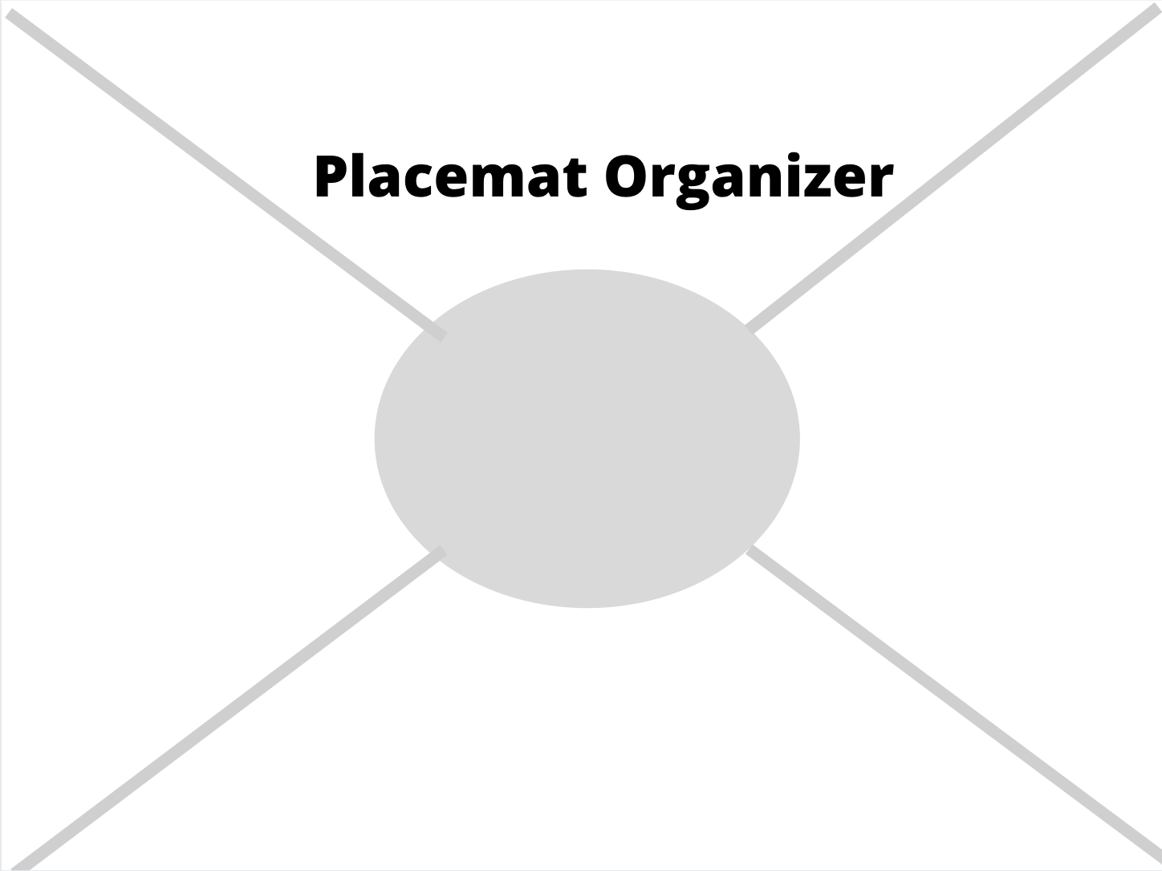

Images for Placemat Activity

Image #1

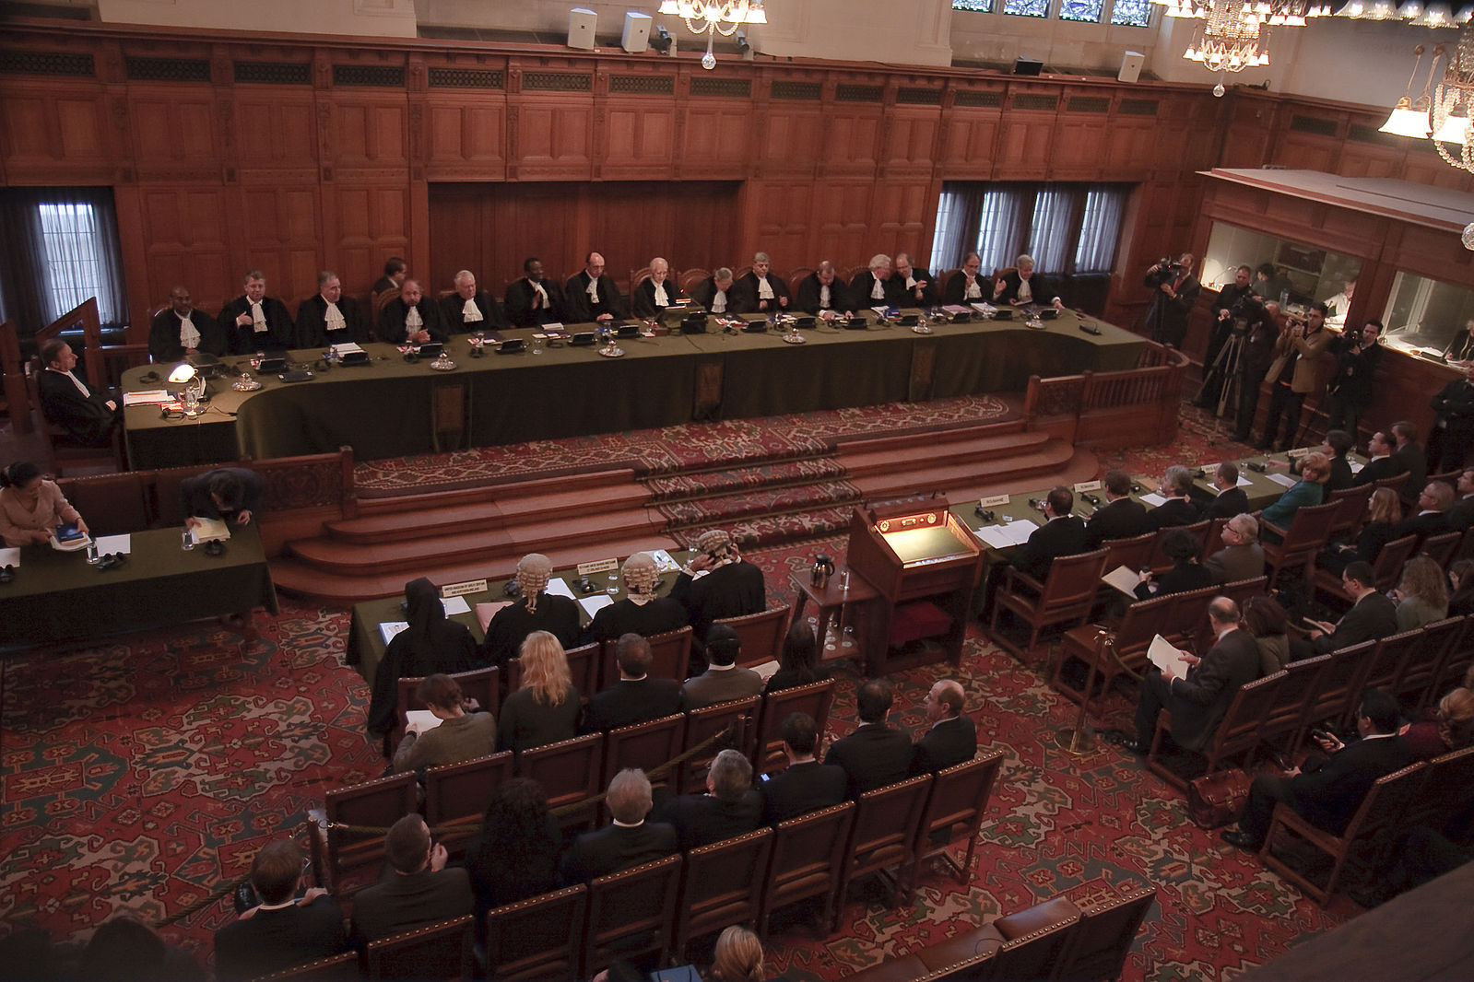
“Grand Hall de Justice de Palais de la Paix.” Wikimedia Commons, Wikimedia, https://commons.wikimedia.org/wiki/File:Grand_Hall_de_Justice_de_Palais_de_La_Paix_%C3%A0_La_Haye_Pays-Bas.jpg
This image shows an audience at the International Court of Justice as it gives an advisory opinion (an opinion on a legal question) on the declaration of independence by Kosovo’s provisional government.

Image #2

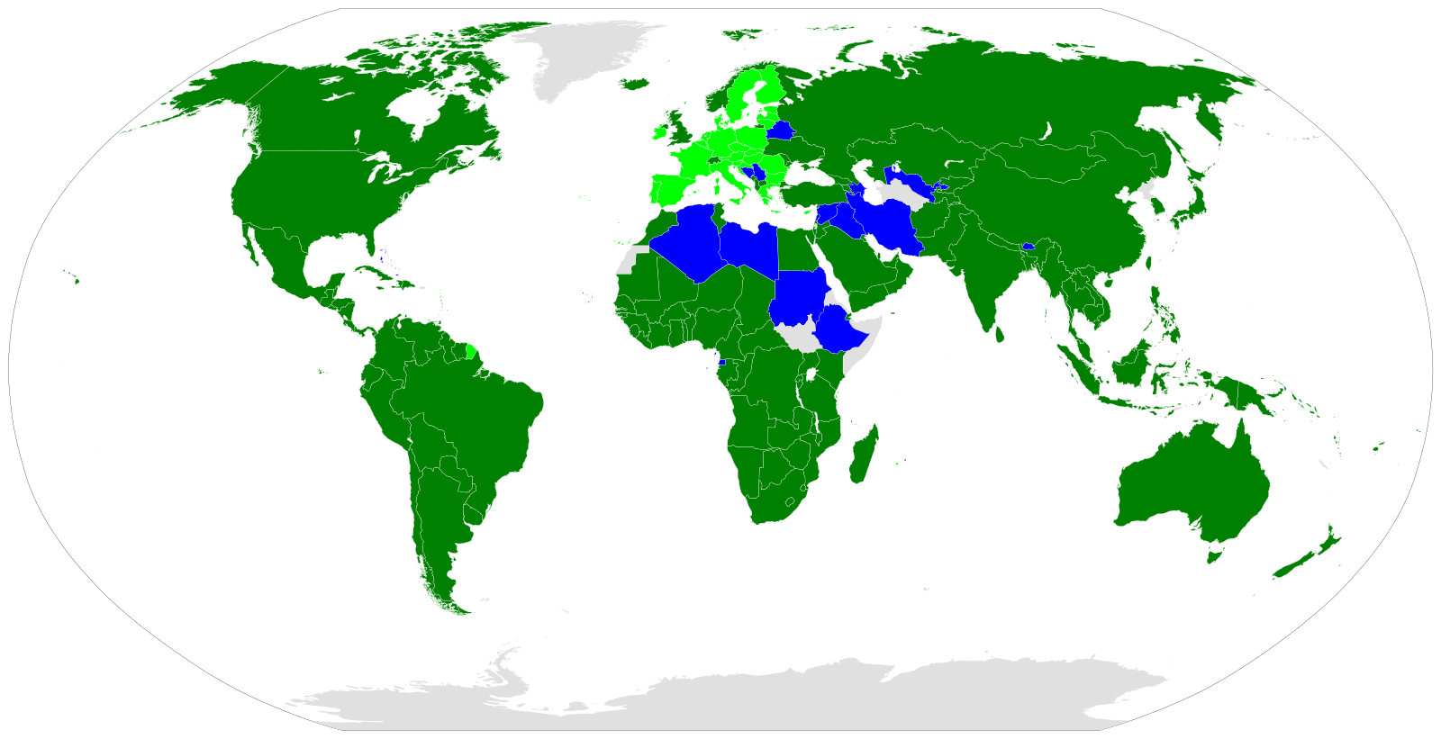
“World Trade Organization Members.” Wikimedia Commons, Wikimedia, commons.wikimedia.org/wiki/File:World_Trade_Organization_Members.svg.
This image shows members of the World Trade Organization. Dark green nations are member states, light green nations are members through the European Union, blue nations are observers, and gray nations have no interaction with the WTO.

Image #3

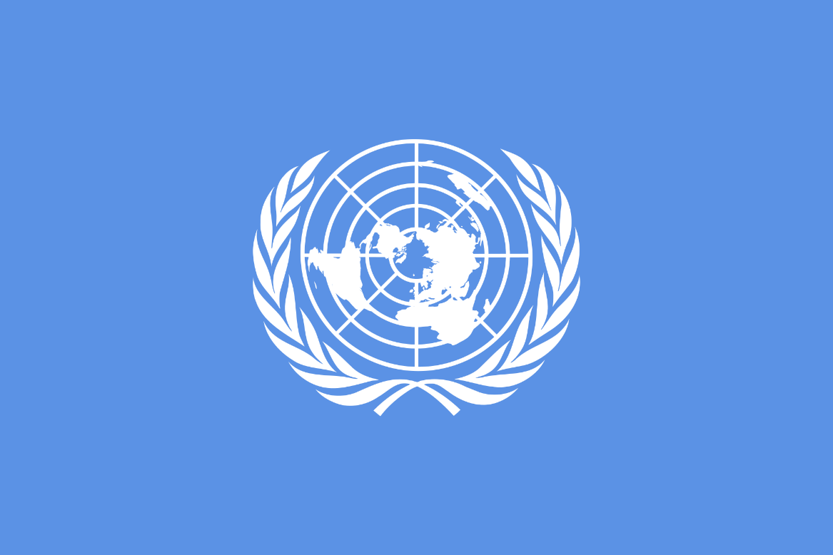

“UN Flag.” Wikimedia Commons, Wikimedia, commons.wikimedia.org/wiki/File:UN_flag.png.
The flag of the United Nations. The flag displays a world map surrounded by two olive branches (a symbol for peace).

Notetaking: The Role of Global Dispute Agencies

Instructions:
Watch the videos on the United Nations, World Trade Organization, and International Court of Justice. Take notes in the chart on the next page. Add your own additional questions or topics for further discussion. You may also want to access the additional web resources for further understanding.

Use these questions to prepare for our class discussion on the role of global dispute institutions and agencies.
- What do these agencies do?
- Identify the stakeholders that could be involved in each of the agencies
- Identify examples of human rights issues addressed or affected by each agencies.
- Identify examples of economic development issues addressed or affected by each agency.
- What controversies exist regarding these agencies?
- Define global change in the context of each agencies
- How effective is each agency? (and how do we measure success or effectiveness?)
- What impact do these institutions have on domestic legal systems?

Video Resources:

The UN is Created - Flashback History https://www.youtube.com/watch?v=FnQESSTouNU

World Trade Organization in One Minute https://www.youtube.com/watch?v=8-voHl16vFE

What is the International Court of Justice? https://www.youtube.com/watch?v=DME-wfbt08c

Additional Resources:
“Building Trade Capacity.” [n.d.] World Trade Organization, World Trade Organization. https://www.wto.org/english/tratop_e/devel_e/build_tr_capa_e.htm
International Criminal Court. [n.d.] https://www.icc-cpi.int/
International Court of Justice. 2021. “List of All Cases.” International Court of Justice. https://www.icj-cij.org/en/list-of-all-cases
United Nations. [n/d/] “What We Do.” United Nations. https://www.un.org/en/sections/what-we-do/
World Trade Organization. 2021. “World Trade Organization - Global Trade.” World Trade Organization. https://www.wto.org/

 | United Nations | World Trade Organization | International Court of Justice
Purpose

Stakeholders

Human Rights Issues

Economic Development Issues

Controversies

Global Change

Effectiveness

Impact on Domestic Legal Systems

Presentation: The Role of Global Dispute Agencies

Instructions: In this project you and a partner will analyze the role of a global dispute institution or agency and their role in an international human rights or an economic development issue. Your group will research a specific issue, analyze it, and present your findings to the class through a digital presentation.

Recommended agencies include: the United Nations, the International Court of Justice, the World Trade Organization and the International Criminal Court.

Essential Question:
In what ways do international organizations and international law affect global change?

Requirements:
- Overview of the global agency’s structure and role
- Overview of the issue (relevant history, stakeholders)
- Analysis (organization’s role, impact on those involved, significance and/or future predictions)
- Each group member will submit their research notes and citations (MLA, at least 2 sources per person)

Presentation Rubric

 | Not Yet Meeting Expectations | Approaching Expectations | Meeting Expectations | Fully Meet or Exceeds Expectations
Research  (individual) | Sources missing or unacceptable | Uses one reputable source only | Uses two reputable sources | Uses three or more reputable sources
Information  (group) | Presentation information  reflects limited knowledge and understanding of case and relevant history | Presentation information reflects some knowledge and understanding of the case and relevant history | Presentation information reflects solid knowledge and understanding of the case and relevant history | Presentation information reflects sophisticated knowledge and understanding of the case and relevant history
Analysis  (group) | Minimal analysis of the role of the ICJ, considering the court’s involvement, impact, and legacy | Some analysis of the role of the ICJ, considering the court’s involvement, impact, and legacy | Analyzes the role of the ICJ, considering the court’s involvement, impact, and legacy | Effectively analyzes the role of the ICJ, considering the court’s involvement, impact, and legacy
Presentation skills  (individual) | Limited eye contact and voice often unclear | Some attempt at eye contact and mostly audible voice | Frequent eye contact, clear and audible voice | Excellent, consistent eye contact, loud voice and engaging style
Presentation Attractiveness and Organization  (group) | -Presentation organization is unclear, often because understanding is weak or non-existent.  - Visual and structural components may be lacking or impede clarity. | -Presentation organization is somewhat clear and appropriate, though may have lapses.  -Visual and structural components assist clarity. | -Presentation organization is generally clear and appropriate.  -Visual and structural components provide clarity. | -Presentation organization is evident, understandable, and appropriate for response.  -Visual and structural components provide excellent clarity.

