Date Reviewed
February 2023

Course
Social Studies 5

Topic
Charter of Rights and Freedoms

Big Idea
Canadian institutions and government reflect the challenge of our diversity.

Essential Question
How does the Charter of Rights and Freedoms protect Canadians?

Learning Standards
Content
Students will know:
- key provisions of the Canadian Charter of Rights and Freedoms

Curricular Competencies
Student will be able to do the following:
- make ethical judgments about events, decisions, or actions that consider the conditions of a particular time and place, and assess appropriate ways to respond. (ethical judgement)

Core Competencies
Communication - I can name rights and freedoms that every Canadian has.

Thinking - I can analyze how the Charter of Rights and Freedoms protects Canadians and reflects our values.

Personal and Social - I can suggest an additional right or freedom that would make Canada a better place.

First People’s Principles of Learning
Learning is…focused on connectedness, on reciprocal relationships, and a sense of place.

Introduction
- Show the 2-minute video The Charter of Rights and Freedoms by TVO (aired Feb 2016).

- Discuss:
- What is the Charter of Rights and Freedoms?
- How does the Charter protect Canadians?
- Project or display the Charter Top 5 Facts infographic.
- Ask:
- What did you already know about the Charter?
- What surprised you?
- What questions do you have?

Pre-Assessment
- Project or display the Rights and Freedoms infographic. Point out that the rights and freedoms are organized into categories.
- Put students into pairs and provide each pair with the “Rights and Freedoms Web”. (Point out that the web only has 6 categories as language rights and minority language education rights are combined.)
- Hand out the “Rights and Freedoms Examples” to each pair. Have partners work together to complete the web by adding examples for each category of rights and freedoms from the Charter. Students can cut out or copy the examples as well as add examples of their own.

Interactive Learning Activities
- Project or display the “Charter Poster”. (Scroll to the 2nd page for English version.) Explain that this is the complete, official version of the Charter. Point out the categories of rights and freedoms as well as the signature and date of the Charter.
- Explain that the Charter is used by the Courts to make decisions. Challenge students to look at real court decisions based on the Charter.
- Put students into 7 groups and give one of the “Charter Case Studies” and one “Case Study Placemat” to each group. Have groups read and discuss assigned case study and then work together to complete “Case Study Placemat”.
- Students should come to consensus on which section of the placemat will be presented by which group member. Ensure that each member has an opportunity to speak.
- When groups are ready, call on each group to present their case study to the class. Ask probing questions and clarify any misunderstandings.

Post-Assessment
Journal
- What does the Canadian Charter of Rights and Freedoms show about what Canadians value?
- What do you feel are the most important rights and freedoms? Why?
- If you could add one right or freedom to the Charter, what would it be? How would it make Canada a better place?

Extension Activities
“Because of the Charter” Infobites
- Have students think of ways that the Charter protects Canadians.
- Hand out sheet “Because of the Charter”. Have students take turns reading aloud the words and discussing the images and symbols in each of these six infobites from the Government of Canada’s Department of Justice.
- Have students think of one way that the Charter protects Canadians. They should use their example to complete the sentence stem, “Because of the Charter…” on the back side of the sheet.
- Have students determine which category of rights or freedoms their example fits into.
- Challenge students to think of ways to represent their examples using images, including symbols.
- Provide students with resources such as blank paper and markers in order to create their infobites.

Additional References

Alberta. “Why are Canada’s Rights and Freedoms important?” [n.d.] http://www.nelson.com/albertasocialstudies/productinfo/gr6_9/docs/abss6ch5.pdf
[Aimed at grades 6 to 9.]

Canada. “The Canadian Charter of Rights and Freedoms.” Department of Justice. 16 Apr. 2020, https://www.justice.gc.ca/eng/csj-sjc/rfc-dlc/ccrf-ccdl/ [Includes Charter-related cases.]

Canada. “A Consolidation of The Constitution Acts 1867 to 1982.” Ottawa: Public Works and Government Services, https://laws-lois.justice.gc.ca/pdf/const_e.pdf

Canada. “Examples of Charter-related Cases.” Department of Justice. 17 Apr. 2019,
https://www.justice.gc.ca/eng/csj-sjc/rfc-dlc/ccrf-ccdl/cases.html

Canada. “Guide to the Canadian Charter of Rights and Freedoms.” 20 June 2020
https://www.canada.ca/en/canadian-heritage/services/how-rights-protected/guide-canadian-charter-rights-freedoms.html

Canada. “Our Country, Our Parliament.” Library of Parliament. Sep. 2020
https://lop.parl.ca/about/parliament/education/ourcountryourparliament/TeacherGuide/activities-sect1-e.asp [Classroom Activities List]

The John Humphrey Centre for Peace and Human Rights and the Department of Canadian Heritage. “Youth Guide to the Canadian Charter of Rights and Freedoms.” [n.d.]
https://www.bestlibrary.org/ss11/files/charterguide.pdf

Materials and Resources
(see next pages)

Because of the Charter

Take turns reading aloud the words and discussing the images and symbols in each of these “infobites” from the Government of Canada’s Department of Justice.
https://www.justice.gc.ca/eng/csj-sjc/rfc-dlc/ccrf-ccdl/resources-ressources.html

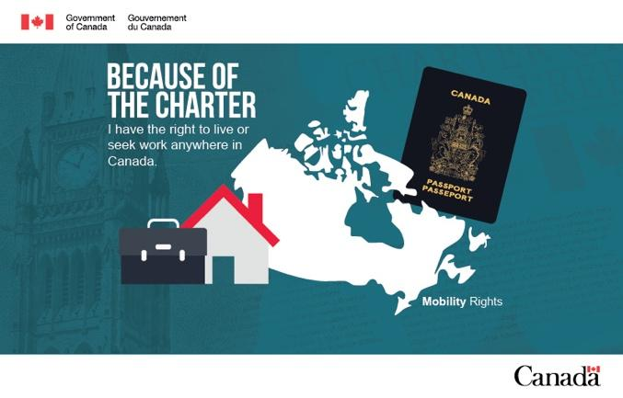
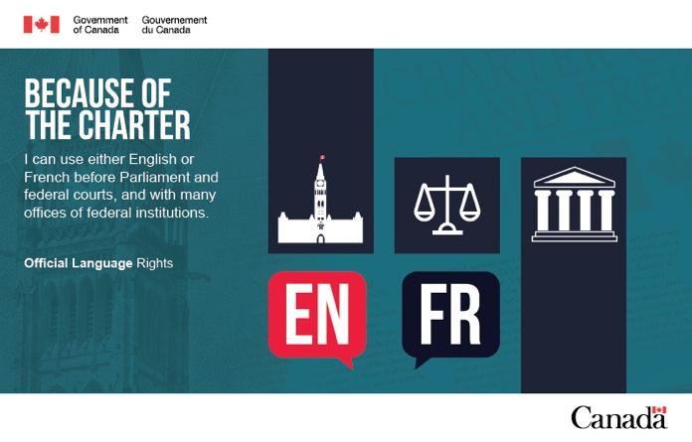
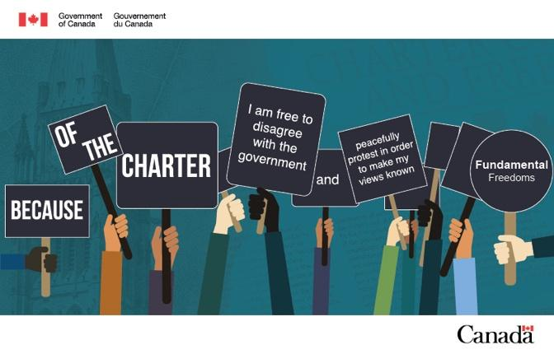
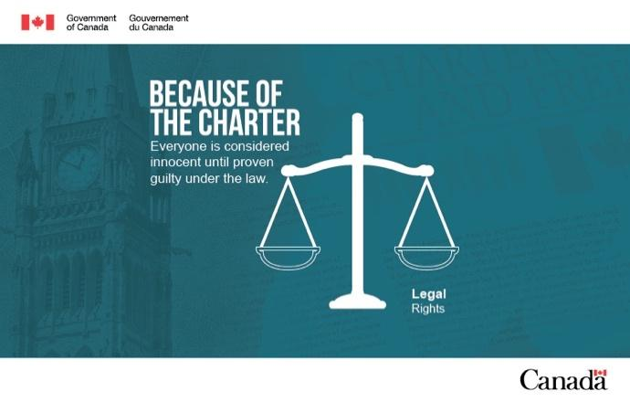
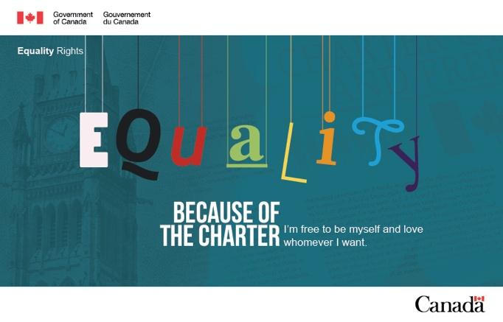
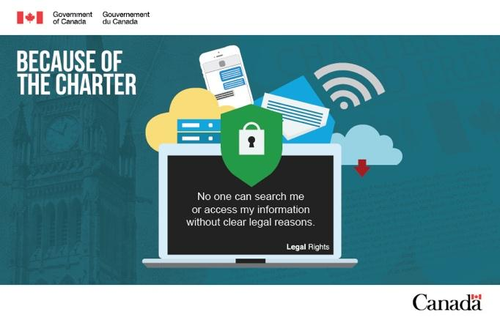

Think of one way that the Charter protects Canadians. Use your example to complete the following sentence:

Because of the charter__________________________________________________________

____________________________________________________________________________

____________________________________________________________________________

What category of rights or freedoms does your example fit into:

____________________________________________________________________________

Think of ways to represent your example using images. List objects and symbols that relate to your example:

____________________________________________________________________________

____________________________________________________________________________

____________________________________________________________________________

Rights and Freedoms Web

Complete the web by adding examples for each category of rights or freedoms from the Charter.

Language Rights
Equality Rights
Mobility Rights
Democratic Rights

Charter of Rights and Freedoms

Fundamental Freedoms

Legal Rights

Rights and Freedoms Examples

Use these examples to complete the Rights and Freedoms Web.

Anyone living in Canada can travel and work anywhere in the country | Newspapers can print what they believe is true
French-speaking people have the right to be educated in French school | Every adult citizen has the right to vote
Everyone is free to believe what they choose | A citizen has the right to leave Canada
No one can be discriminated against based on race, ethnicity, colour, religion, sex, age, or mental or physical disability | Anyone who is arrested has the right to a lawyer and a fair trial
Every adult citizen has the right to run for public office | Everyone has the right to speak the language of their choice
All people are innocent until proven guilty | Everyone has the right to be treated with respect

Charter Case Studies
Case Study 1: Religious freedom in school
Gurbaj Singh Multani was an orthodox Sikh student who believed that his religion required him to wear a kirpan at all times, including at school. A kirpan is a religious object worn by people of Sikh faith that looks like a dagger. Multani and his parents agreed with the school board’s request that he seal the kirpan in his clothing at all times while wearing it at school. However, the school board’s council of commissioners told Multani that he could not wear the kirpan to school even if it was sealed in his clothing because bringing dangerous objects to school violated the school’s code of conduct.
The Supreme Court found that the council’s decision infringed Multani’s freedom of religion. Multani sincerely believed that his Sikh faith required him to wear the kirpan and the prohibition on wearing it would have prevented him from attending public school altogether. The school board had not justified that a full ban on wearing kirpans in school was a reasonable limit on freedom of religion. There had never been a violent incident involving a kirpan at school and there was no evidence that the kirpan itself was a symbol of violence. The Court’s decision provides important guidance on the relationship between religious freedom, multiculturalism and public education in Canada. A total ban on wearing kirpans in schools ignores the importance of respect for minorities and religious tolerance in Canada’s multicultural society.
Multani v. Commission scolaire Marguerite-Bourgeoys, [2006] 1 SCR 256
_____________________________________________________________________
Case Study 2: Programs aimed at helping disadvantaged groups can be consistent with Charter’s equality rights protections
As part of a government program to improve the economic situation of Indigenous communities near the mouth of the Fraser River, communal fishing licences allowed members of three Indigenous bands to catch salmon at a designated time. John Kapp and a group of commercial fishers said that they were being discriminated against because they weren’t allowed to fish for salmon at the mouth of the Fraser River during these times.
The Supreme Court found no discrimination because the special fishing privileges for Indigenous groups were granted for the legitimate purpose of assisting those disadvantaged communities. This case made it clear that governments can seek to improve the lives of historically disadvantaged groups by passing laws and creating programs intended to help them. It also recognized that when properly designed, these laws and programs can be entirely compatible with equality rights protection under the Charter
R. v. Kapp, 2008 SCC 41
Case Study 3: Awards for Charter damages
The Vancouver police received information that someone planned to throw a pie at the Prime Minister during a ceremony. The officers mistakenly identified that person as Alan Ward and handcuffed him. Ward protested his detention and was arrested for breach of the peace. He was taken to the police station, where he was detained for over 4 hours and subjected to a strip search. Later, the police determined that they lacked the grounds to charge Ward for attempted assault and let him go.
Ward argued that his right to be free from unreasonable search or seizure was breached. The Supreme Court agreed and upheld an award of $5,000 for the strip search.
In doing so, the Court established the framework for awarding Charter damages. Its decision was built on a previous judgment, where the Supreme Court explained that courts have the very broad power to give “just and appropriate” remedies when a government action violates the Charter. The Court held/found that damages can be awarded if the victim of the Charter violation shows why damages are fair and appropriate. Courts will consider whether damages would compensate the victim for the harm done, justify the importance of the right, or deter future breaches.
Vancouver (City) v. Ward, 2010 SCC 27
Case Study 4: Balancing religious freedom with trial fairness
After N.S. was assaulted, the Crown called her as a witness in the preliminary inquiry of her accused attackers. For religious reasons, N.S. asked to testify wearing a niqab, a head scarf that covers the face except the eyes. The judge ordered her to remove her niqab, but N.S. argued that making her do so would infringe her right to religious freedom.
The majority of the Supreme Court held that if wearing the niqab poses no serious risk to trial fairness, a witness who wishes to wear it for sincere religious reasons may do so. This case requires judges to try to find a way to balance freedom of religion and trial fairness if the two rights conflict with each other. More generally, this case highlights the need for public institutions to accommodate religious difference as much as possible so everyone feels respected, while still upholding other Charter-protected rights and freedoms.
R. v. N.S., 2012 SCC 72

Case Study 5: The right to strike

In 2008, Saskatchewan passed legislation to prevent certain public service workers from going on strike. A meaningful collective bargaining process requires employees to be able to strike when good-faith negotiations break down. The legislation did not offer any other way for resolving bargaining disputes, such as arbitration. The Saskatchewan Federation of Labour and a group of other unions claimed that the new laws violated their right to freedom of association.
The Supreme Court found that the laws were unconstitutional on the basis that they interfered with a meaningful process of collective bargaining. They went beyond what was reasonably required to ensure the uninterrupted delivery of essential public services during a strike. For the first time, the Court agreed that freedom of association includes the right to strike.
Saskatchewan Federation of Labour v. Saskatchewan, 2015 SCC 4
_____________________________________________________________________
Case Study 6: Reasonable expectation of privacy in text messages
Nour Marakah sent text messages regarding illegal transactions in firearms to his accomplice, Andrew Winchester. In the course of their investigation, the police executed several search warrants, subsequently arresting both Mr. Marakah and Mr. Winchester and seizing both of their cell phones. Both phones were put through a forensic search, which revealed text messages implicating both men in gun trafficking.
At his trial, Mr. Marakah argued that the incriminating messages should not be admitted into evidence because they were obtained in violation of his s. 8 right against unreasonable search and seizure. The issue before the Supreme Court was whether Mr. Marakah had a reasonable expectation of privacy in the messages on Mr. Winchester's phone.
The majority of the Supreme Court affirmed the highly private nature of electronic conversations, explaining that text conversations allow people to share details of their "activities, relationships, and even their identities that they would never reveal to the world at large". The fact that text messaging inherently involves some loss of control over the electronic conversation - because it involves creating a permanent record of the conversation that is in the possession of another person - does not mean that the sender of a text message necessarily loses their reasonable expectation that the government will not access the conversation. Under the circumstances, Mr. Marakah retained a reasonable expectation of privacy in the copies of the text messages found on Mr. Winchester's phone.
Because the search of Mr. Winchester's phone was not a valid search incident to arrest, it was not authorized by law and violated Mr. Marakah's s. 8 rights. The Court concluded that the evidence should be excluded under s. 24(2) of the Charter.
R. v. Marakah, 2017 SCC 59
Case Study 7: Right to vote for all non-resident Canadian citizens
Gillian Frank and Jamie Duong were Canadian citizens who lived abroad. They nevertheless maintained strong ties to Canada and wanted to vote in federal elections. They could not do so because the Canada Elections Act prohibited voting by Canadian citizens living outside of Canada for more than five years. They challenged the provisions as an unjustifiable violation of section 3 of the Charter, which protects the right of citizens to vote.
The majority of the Supreme Court held that the challenged provisions infringed voting rights and were not justified by section 1 of the Charter. Limiting the right to vote of non-resident citizens was not minimally impairing, and there was little to justify the choice of five years as the threshold, or to show how it was tailored to respond to a specific problem. The majority reasoned that the residence requirement emerged at a time when citizens were generally unable to travel as easily and extensively as they do today and tended to spend their lives in one community. In contrast, citizens today have an unprecedented ability to move throughout the world and maintain communications. The Court emphasized that citizenship, not residence, defines Canada's political community and underlies the right to vote.
The Court reiterated that the right to vote is a basic and important democratic right, and any limitation of the right will be subject to a stringent justification standard. The parts of the Canada Elections Act that limit the voting rights of non-resident citizens were repealed and are no longer in force.
Frank v. Canada (Attorney General), 2019 SCC 1

Case Study Placemat

Case Study # ____________

Who?

What?

Where?

When?

Why?

How?

What specific rights or freedoms were involved?

Which section(s) of the Charter does this relate to?

Do you agree with the Court’s decision? Why or why not?

What did the Court decide?

